

2023-2024 FALL SEMESTER

ECON 485 PROJECT

Elvin YILDIRIM

19232810034

The sales activities of a store X are shown in the table below. Jewelry, electronics, furniture, and clothes are all sold in this store.

Products are delivered from the store warehouse if it has inventory; if not, they are brought in from the central warehouse. The order will be canceled but the client record will be in the system in the event that the product is returned or cannot be delivered for any reason. The payment plan for just the returned product will be canceled if more than one product has been sold. For every payment transaction in the payment plan, a counter record is opened and deducted from the overall amount of debt. In the payment plan, every payment has a date. On the same day, the counter record for refunds and cancellations is opened. A distinct record is opened for the payment at the time of payment. Every product within the store has a unique ID defined for it. These ID-based amounts are included in orders. Each product's ID, pricing, production ID, stock numbers, payment methods, and client details are all listed in this table

SCENARIO:

The client arrives at the shop. The merchandise he purchased online will be delivered to him by the retailer. With the assistance of the sales agent in the appropriate department, he locates the product he wants. The mechanism is used to query the product's price. The device can additionally identify any changes made to the product's price.These operations are carried out using the product ID. The quantity of the product and its availability in the store are verified. If the goods is in stock, the sales procedure and the merchandise are delivered from the store together. The customer presents the document proving they made the online payment to the cash register, and a record is opened at the cash desk for them.

| **Customer ID** | **Customer Name** | **Product ID** | **Product Name** | **Category** | **Stock Code** | **Payment** | **Date** | **Address** | | **Payment Method** | **Order Date** |
| --- | --- | --- | --- | --- | --- | --- | --- | --- | --- | --- | --- |
| 001 | Elvin Yıldırım | P001 | Product A | Electronic | E001 | $60.00 | 28.12.2023 | 123 Street, City A | Credit Card | | 2022-01-15 |
| 001 | Elvin Yıldırım | P002 | Product B | Clothing | C002 | $40.00 | 28.12.2023 | 123 Street, City A | Credit Card | | 2022-01-15 |
| 002 | Eren Şahin | P003 | Product C | Furniture | F003 | $125.00 | 29.12.2023 | 456 Avenue, City B | Cash | | 2022-01-16 |
| 003 | Ezgi Yıldız | P004 | Product A | Electronic | E004 | $240.00 | 01.01.2024 | 789 Road, City C | Credit Card | | 2022-01-17 |
| 004 | Furkan Güler | P002 | Product B | Jewelery | J002 | $139.00 | 05.01.2024 | 101 Park, City D | Cash | | 2022-01-18 |

1. TABLE OF PRODUCTS: Table with basic information for each product. Products are coded with letters and numbers to make them easy to find. Electronic products are named product A, and product id is listed according to the number of products produced. Elvin and Ezgin purchased identical electronic items. Elvin Yıldırım's production is the first one made, but the other person's is the fourth. Nevertheless, the production IDs of the two are P001 and P004, respectively. Since the IDs provided to the production will be credited to the individuals in the event that the products are repaired under insurance, these IDs will simplify the task.

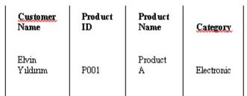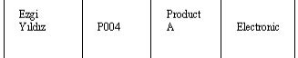

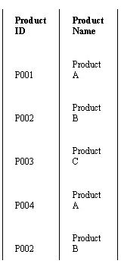

1. CATEGORY / STOCK CODE: It is used to track the product stock amount in each warehouse.

The categories are numbered and the products are coded with a special acronym, SC, to make it easy to locate the stocks.

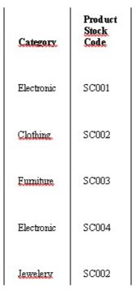

1. ORDERS TABLE: It is used to track customer orders. The table below illustrates that on a single day, Elvin Yıldırım, the customer, placed two separate orders, but his customer ID was only given one.

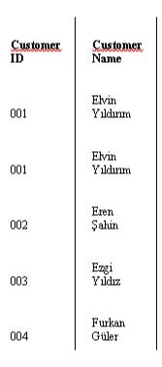 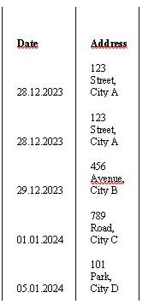

1. PAYMENT METHOD: Payment plans for customers are monitored with it. A payment method is any of the different ways that consumers can pay for the goods or services they are buying. Payment options vary depending on the type of store—online or physical. Cash, gift cards, debit cards, credit cards, and mobile payments are among the often accepted payment methods.

